# Subsetting Rows - Region is Mountain

This document includes the question, the solution, and a breakdown of the code provided in the screenshot.

## Uploaded Screenshot

Below is the screenshot of the task:

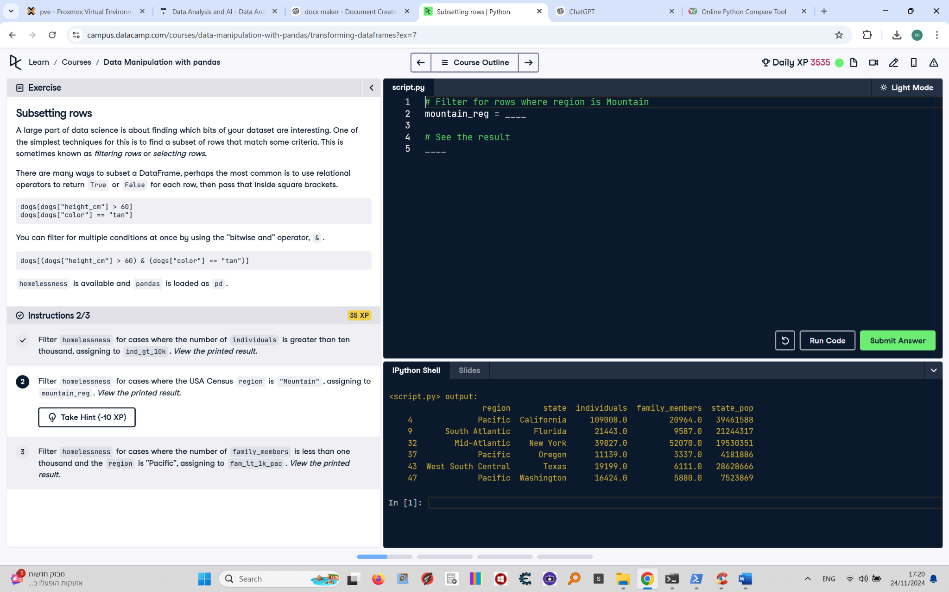

## Question

Filter `homelessness` for cases where the region is "Mountain", assigning the result to `mountain_reg`. View the printed result.

## Answer

# Filter for rows where region is Mountain  
mountain_reg = homelessness[homelessness["region"] == "Mountain"]  
  
# See the result  
print(mountain_reg)

## Code Explanation

# Explanation of the code:

1. `homelessness["region"] == "Mountain"`: This creates a boolean mask, where each row evaluates to `True` if the value in the `region` column matches "Mountain", and `False` otherwise.

2. `homelessness[homelessness["region"] == "Mountain"]`: Filters the `homelessness` DataFrame by keeping only rows where the mask is `True`.

3. `mountain_reg`: Stores the filtered DataFrame for further use.

4. `print(mountain_reg)`: Prints the resulting DataFrame to verify the filter.